Homework # 13 – Chi-Square Problems

Problem #1

Data:

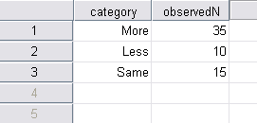

- Hand Calculation:
- A chi-square goodness-of-fit is the appropriate test in this situation.
- H_{a}: Students’ responses differ across the categories.
- H₀: Students’ responses do not differ across the categories.
- Contingency table:

Importance of a College Degree
More | Less | Same
35  (20) | 10  (20) | 15  (20)

- Degrees of freedom, df = 3-1 = 2
- χ² =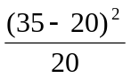 + 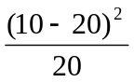+ 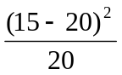
= 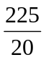 + 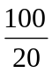 + 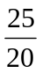 = 11.25 + 5 + 1.25 = 17.5

Cohen’s phi = 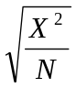 = 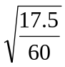 = 0.54
=> The effect size is large.

- Critical χ²_{critical} = 13.82 at p = 0.001 for df = 2
- The test is significant.
- Adjusted residuals not applicable.
- Conclusion:
A randomly selected 60 high school students were surveyed to test whether the high school students are equally concern regarding the importance of getting a college degree. The sample students were asked about their belief of college education as more important, or less important or almost same. Observed and expected frequencies are shown in the above contingency table. A chi-square goodness-of-fit test was executed by hand calculation and found a significant result [χ² (2, N=60) = 17.5, p = 0.001]. Cohen’s phi was calculated as 0.54 that indicated a large effect size. Thus, the null hypothesis of the assumption that students’ responses do not differ across the categories was rejected. Finally looking back to the contingency table it was concluded that the high school students consider that a college degree is more important to them.
A similar result was found suing the SPSS for Windows that is shown below.

- SPSS Command:

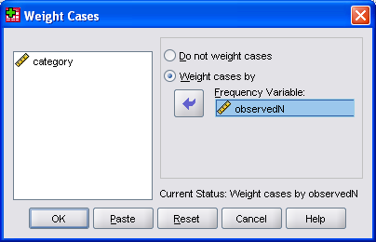

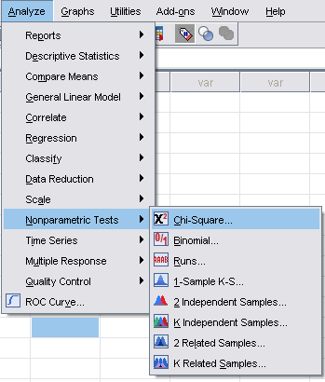

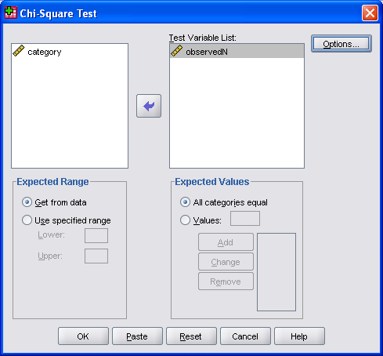

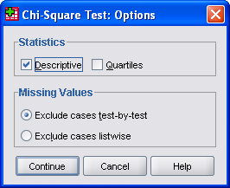

- SPSS Output:

NPar Tests
Descriptive Statistics
 | N | Mean | Std. Deviation | Minimum | Maximum
observedN | 60 | 25.83 | 11.053 | 10 | 35

Chi-Square Test

Frequencies
observedN
 | Observed N | Expected N | Residual
10 | 10 | 20.0 | -10.0
15 | 15 | 20.0 | -5.0
35 | 35 | 20.0 | 15.0
Total | 60

Test Statistics
 | observedN
Chi-Square | 17.500ª
df | 2
Asymp. Sig. | .000
a. 0 cells (.0%) have expected frequencies less than 5. The minimum expected cell frequency is 20.0.

Problem #2
Data:

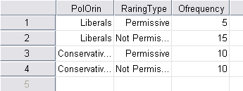

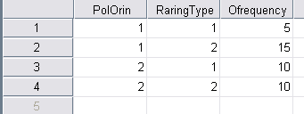

- Hand Calculation:
- A chi-square test of independence is the appropriate test in this situation.
- H_{a}: There is a relationship between political orientation and child-rearing permissiveness
- H₀: There is no relationship between political orientation and child-rearing permissiveness
- Contingency table:

 | Child-rearing Permissiveness
Political Orientation | Permissive | Not Permissive | Total
Liberal | 5  (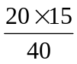 = 7.5) | 15  (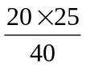 = 12.5) | 20
Conservative | 10  ( = 7.5) | 10  ( = 12.5) | 20
Total | 15 | 25 | 40

- Degrees of freedom, df = (2-1)(2-1) = 1
- χ² =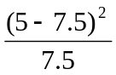 + 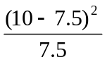+ 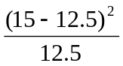 + 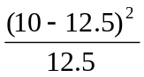
= 0.833 + 0.833 + 0.5 + 0.5 = 2.67

Cramer’s v = 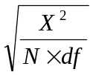 = 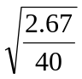 = 0.258
=> The effect size is small to medium

- Critical χ²_{critical} = 3.84 at p = 0.05 for df = 1
- The test is non-significant.
- Adjusted residuals not applicable.
- Conclusion:

To investigate the relationship between political orientation and child-rearing permissiveness, a number of 40 randomly selected subjects were interviewed and found their opinion as shown in the above contingency table. Observed and expected frequencies are shown in the above contingency table. Then a chi-square test of independence was executed by hand calculation to test whether there is a relationship between political orientation and child-rearing permissiveness. The result showed a non-significant result [χ² (1, N=40) = 2.67, p >.05]. Cramer’s v was calculated as 0.258 that indicated a small to medium effect size. Thus, the null hypothesis of no relationship between political orientation and child-rearing permissiveness was failed to reject, and found no evidence that there is a relationship between political orientation and child-rearing permissiveness.
A similar result was found suing the SPSS for Windows that is shown below.

- SPSS Command:

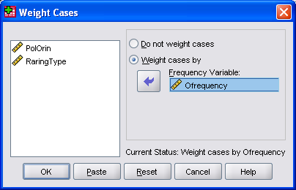

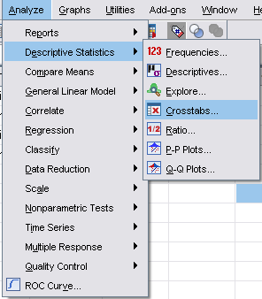

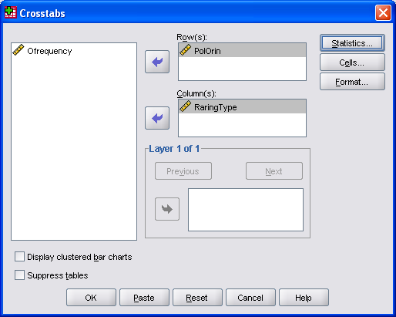

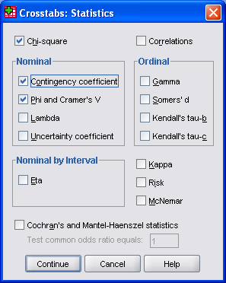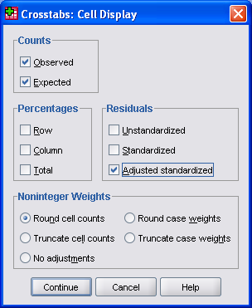

- SPSS Output:

Crosstabs
Case Processing Summary
 | Cases
 | Valid |  | Missing |  | Total
 | N | Percent | N | Percent | N | Percent
PolOrin * RaringType | 40 | 100.0% | 0 | .0% | 40 | 100.0%

PolOrin * RaringType Crosstabulation
 |  |  | RaringType
 |  |  | Permissive | Not Permissive | Total
PolOrin | Liberals | Count | 5 | 15 | 20
PolOrin | Liberals | Expected Count | 7.5 | 12.5 | 20.0
PolOrin | Liberals | Adjusted Residual | -1.6 | 1.6
PolOrin | Conservatives | Count | 10 | 10 | 20
PolOrin | Conservatives | Expected Count | 7.5 | 12.5 | 20.0
PolOrin | Conservatives | Adjusted Residual | 1.6 | -1.6
PolOrin | Total | Count | 15 | 25 | 40
PolOrin | Total | Expected Count | 15.0 | 25.0 | 40.0

Chi-Square Tests
 |  | Value | df |  | Asymp. Sig. (2-sided) |  | Exact Sig. (2-sided) |  | Exact Sig. (1-sided)
Pearson Chi-Square |  | 2.667ª | 1 |  | .102
Continuity Correction^{b} |  | 1.707 | 1 |  | .191
Likelihood Ratio |  | 2.706 | 1 |  | .100
Fisher's Exact Test |  |  |  |  |  |  | .191 |  | .095
Linear-by-Linear Association |  | 2.600 | 1 |  | .107
N of Valid Cases |  | 40
a. 0 cells (.0%) have expected count less than 5. The minimum expected count is 7.50.
b. Computed only for a 2x2 table
Symmetric Measures
 |  |  |  | Value |  | Approx. Sig.
Nominal by Nominal | Phi |  |  | -.258 |  | .102
Nominal by Nominal | Cramer's V |  |  | .258 |  | .102
Nominal by Nominal | Contingency Coefficient |  |  | .250 |  | .102
Nominal by Nominal | N of Valid Cases |  |  | 40

Problem #3

Data:

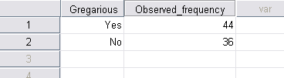

SPSS Output:

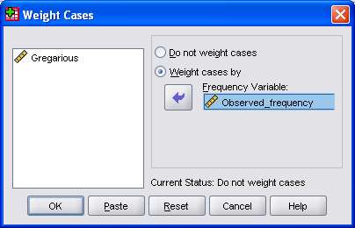

NPar Tests

Descriptive Statistics
 | N | Mean | Std. Deviation | Minimum | Maximum
Observed_frequency | 80 | 40.40 | 4.005 | 36 | 44

Chi-Square Test

Observed_frequency
 | Observed N | Expected N | Residual
36 | 36 | 40.0 | -4.0
44 | 44 | 40.0 | 4.0
Total | 80

Test Statistics
 | Observed_frequency
Chi-Square | .800ª
df | 1
Asymp. Sig. | .371
a. 0 cells (.0%) have expected frequencies less than 5. The minimum expected cell frequency is 40.0.

Results:

- A chi-square goodness-of-fit is the appropriate test in this situation.
- H_{a}: The responses differ in the opinion that the overweight people are gregarious.
- H₀: The responses do not differ in the opinion that the overweight people are gregarious.
- Contingency table:

Yes | No
44  (40) | 36  (40)

- Degrees of freedom, df = 2-1 = 1
- χ² = 0.8
Cohen’s phi = = 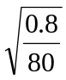 = 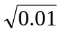 = 0.1
=> The effect size is large

- Critical χ²_{critical} = 3.84 at p = 0.05 for df = 1
- The test is not significant.
- Adjusted residuals not applicable.
- Conclusion:
A randomly selected 80 subjects were surveyed in order to test whether the overweight people are gregarious. Observed and expected frequencies are shown in the above contingency table. Using SPSS for Windows a chi-square goodness-of-fit test was executed and found a non-significant result [χ² (1, N=80) = 0.8, p > 0.05]. Cohen’s phi was calculated as 0.1 that indicated a small effect size. That failed to reject the null hypothesis of the assumption that the overweight people are gregarious. Thus, it was concluded that the study result did not produce any evidence that the overweight people are gregarious.

Problem #4
Data:

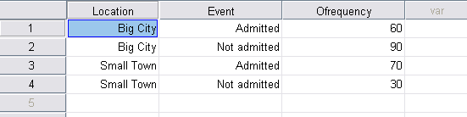

SPSS Output:

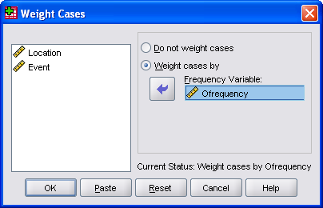

Crosstabs

Case Processing Summary
 | Cases
 | Valid |  | Missing |  | Total
 | N | Percent | N | Percent | N | Percent
Location * Event | 250 | 100.0% | 0 | .0% | 250 | 100.0%

Location * Event Crosstabulation
 |  |  | Event
 |  |  | Admitted | Not admitted | Total
Location | Big City | Count | 60 | 90 | 150
Location | Big City | Expected Count | 78.0 | 72.0 | 150.0
Location | Big City | Std. Residual | -2.0 | 2.1
Location | Big City | Adjusted Residual | -4.7 | 4.7
Location | Small Town | Count | 70 | 30 | 100
Location | Small Town | Expected Count | 52.0 | 48.0 | 100.0
Location | Small Town | Std. Residual | 2.5 | -2.6
Location | Small Town | Adjusted Residual | 4.7 | -4.7
Location | Total | Count | 130 | 120 | 250
Location | Total | Expected Count | 130.0 | 120.0 | 250.0

Chi-Square Tests
 | Value | df | Asymp. Sig. (2-sided) | Exact Sig. (2-sided) | Exact Sig. (1-sided)
Pearson Chi-Square | 21.635ª | 1 | .000
Continuity Correction^{b} | 20.449 | 1 | .000
Likelihood Ratio | 22.097 | 1 | .000
Fisher's Exact Test |  |  |  | .000 | .000
Linear-by-Linear Association | 21.548 | 1 | .000
N of Valid Cases | 250
a. 0 cells (.0%) have expected count less than 5. The minimum expected count is 48.00.
b. Computed only for a 2x2 table

Symmetric Measures
 |  | Value | Approx. Sig.
Nominal by Nominal | Phi | -.294 | .000
Nominal by Nominal | Cramer's V | .294 | .000
Nominal by Nominal | Contingency Coefficient | .282 | .000
Nominal by Nominal | N of Valid Cases | 250

Results:
- A chi-square test of independence was the appropriate test in this situation.
- H_{a}: Big city dwellers and small town dwellers differ in their helpfulness to strangers.
- H₀: Big city dwellers and small town dwellers do not differ in their helpfulness to strangers.
- Contingency table:

 | Helpfulness to Strangers
Location | Admit | Not Admit | Total
Big City | 60  (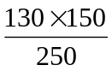 = 78) | 90  (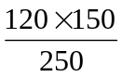 = 72) | 150
Small Town | 70  (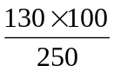 = 52) | 30  (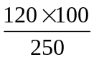 = 48) | 100
Total | 130 | 120 | 250

- Degrees of freedom, df = 2-1 = 1
- χ² = 21.635
Cramers’s v = = 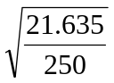 = 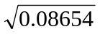 = 0.2942
=> The effect size is small to medium.

- Critical χ²_{critical} = 10.827 at p = 0.001 for df = 1
- The test is significant
- Adjusted Residuals:

Location | Admit | Not Admit
Big City | -4.7 | 4.7
Small Town | 4.7 | -4.7

- Conclusion:
A randomly selected 250 subjects; 150 from a big City and 100 from a small town, were surveyed in order to test whether the helpfulness to strangers differ among the big city dwellers and small town dwellers. Observed and expected frequencies are shown in the above contingency table. Using SPSS for Windows a chi-square test of independence was executed and found a significant result [χ² (1, N=250) = 021.635, p < 0.001]. Cramer’s v was calculated as 0.294 that indicated a small to medium effect size. That rejects the null hypothesis of the assumption that big city dwellers and small town dwellers do not differ in their helpfulness to strangers. Again looking back to the contingency table, it was concluded that the study result produced significant evidence that the small town dwellers are more helpful than the big city dwellers.
Problem #5

Data:

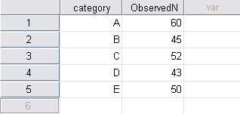

SPSS Output:

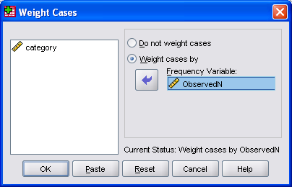

NPar Tests

Chi-Square Test
Frequencies
ObservedN
 | Observed N | Expected N | Residual
43 | 43 | 50.0 | -7.0
45 | 45 | 50.0 | -5.0
50 | 50 | 50.0 | .0
52 | 52 | 50.0 | 2.0
60 | 60 | 50.0 | 10.0
Total | 250

Test Statistics
 | ObservedN
Chi-Square | 3.560ª
df | 4
Asymp. Sig. | .469
a. 0 cells (.0%) have expected frequencies less than 5. The minimum expected cell frequency is 50.0.

Results:

- A chi-square goodness-of-fit is the appropriate test in this situation.
- H_{a}: There is a difference in the preference of coffee brands.
- H₀: There is no difference in the preference of coffee brands.
- Contingency table:

Coffee Brands
A | B | C | D | E
60  (50) | 45  (50) | 52  (50) | 43  (50) | 50  (50)

- Degrees of freedom, df = 5-1 = 4
- χ² = 3.56
Cohen’s phi = = 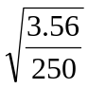 = 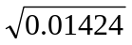 = 0.12
=> The effect size issamll

- Critical χ²_{critical} = 9.488 at p = 0.05 for df = 4
- The test is not significant.
- Adjusted residuals not applicable.
- Conclusion:
A randomly selected 250 subjects were surveyed in order to test whether there is a difference in the preference of the new coffee brand A among the existing coffee brands, B, C, D, E, and F. Observed and expected frequencies are shown in the above contingency table. Using SPSS for Windows a chi-square test of independence was executed and found a non-significant result [χ² (2, N=250) = 3.56, p > 0.05]. Cohen’s phi was calculated as 0.12 that indicated a small effect size. That failed to reject the null hypothesis that there is no difference in the preference of coffee brands. Thus, it was concluded that the study result produced no evidence that the new coffee brand A was preferred to the other existing four brands.
Problem #6
Data:

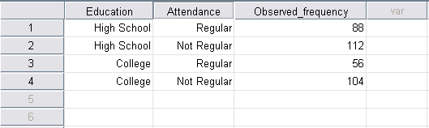

SPSS Output:

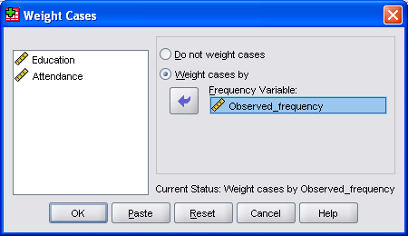

Crosstabs

Case Processing Summary
 | Cases
 | Valid |  | Missing |  | Total
 | N | Percent | N | Percent | N | Percent
Education * Attendance | 360 | 100.0% | 0 | .0% | 360 | 100.0%

Education * Attendance Crosstabulation
 |  |  | Attendance
 |  |  | Regular | Not Regular | Total
Education | High School | Count | 88 | 112 | 200
Education | High School | Expected Count | 80.0 | 120.0 | 200.0
Education | High School | Std. Residual | .9 | -.7
Education | High School | Adjusted Residual | 1.7 | -1.7
Education | College | Count | 56 | 104 | 160
Education | College | Expected Count | 64.0 | 96.0 | 160.0
Education | College | Std. Residual | -1.0 | .8
Education | College | Adjusted Residual | -1.7 | 1.7
Education | Total | Count | 144 | 216 | 360
Education | Total | Expected Count | 144.0 | 216.0 | 360.0

Chi-Square Tests
 |  | Value | df |  | Asymp. Sig. (2-sided) |  | Exact Sig. (2-sided) |  | Exact Sig. (1-sided)
Pearson Chi-Square |  | 3.000ª | 1 |  | .083
Continuity Correction^{b} |  | 2.637 | 1 |  | .104
Likelihood Ratio |  | 3.014 | 1 |  | .083
Fisher's Exact Test |  |  |  |  |  |  | .104 |  | .052
Linear-by-Linear Association |  | 2.992 | 1 |  | .084
N of Valid Cases |  | 360
a. 0 cells (.0%) have expected count less than 5. The minimum expected count is 64.00.
b. Computed only for a 2x2 table
Symmetric Measures
 |  |  |  | Value |  | Approx. Sig.
Nominal by Nominal | Phi |  |  | .091 |  | .083
Nominal by Nominal | Cramer's V |  |  | .091 |  | .083
Nominal by Nominal | Contingency Coefficient |  |  | .091 |  | .083
Nominal by Nominal | N of Valid Cases |  |  | 360

Results:

- A chi-square test of independence was the appropriate test in this situation.
- H_{a}: There is a relationship between church attendance and their education level.
- H₀: There is no relationship between church attendance and their education level.
- Contingency table:

 | Church Attendance
Education Level | Regular | Not Regular | Total
High School Graduates | 88  (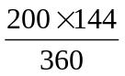 = 80) | 112  (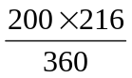 = 120) | 200
College Graduates | 56  (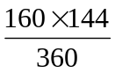 = 64) | 104  (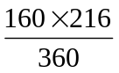 = 96) | 160
Total | 144 | 216 | 360

- Degrees of freedom, df = (2-1)(2-1) = 1
- χ² = 3.0
Cramer’s v = = 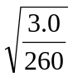 = 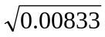 = 0.0912
=> The effect size is small

- Critical χ²_{critical} = 3.84 at p = 0.05 for df = 1
- The test is not significant.
- Adjusted residuals not applicable.
- Conclusion:
A randomly selected 360 high school and college graduates were surveyed to test whether there is a relationship between church attendance and their education level. Observed and expected frequencies are shown in the above contingency table. Using SPSS for Windows a chi-square test of independence was executed and found a non-significant result [χ² (1, N=360) = 3.0, p > 0.05]. Cramer’s v was calculated as 0.0912 that indicated a small effect size. That failed to reject the null hypothesis that there is no is no relationship between church attendance and education level. Thus, it was concluded that the study result produced no evidence that there is a relationship between church attendance and their education level.
Problem #7
Data:

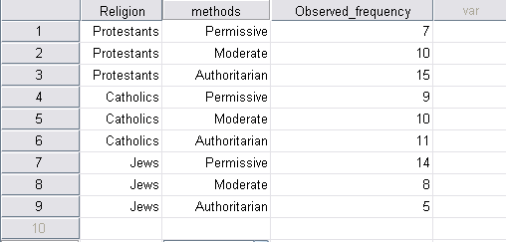

SPSS Output:

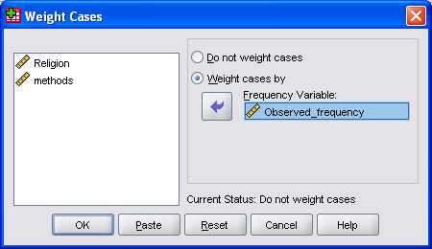

Crosstabs
Case Processing Summary
 | Cases
 | Valid |  | Missing |  | Total
 | N | Percent | N | Percent | N | Percent
Religion * methods | 89 | 100.0% | 0 | .0% | 89 | 100.0%

Religion * methods Crosstabulation
 |  |  | methods
 |  |  | Permissive | Moderate | Authoritarian | Total
Religion | Protestants | Count | 7 | 10 | 15 | 32
Religion | Protestants | Expected Count | 10.8 | 10.1 | 11.1 | 32.0
Religion | Protestants | Std. Residual | -1.2 | .0 | 1.2
Religion | Protestants | Adjusted Residual | -1.8 | .0 | 1.8
Religion | Catholics | Count | 9 | 10 | 11 | 30
Religion | Catholics | Expected Count | 10.1 | 9.4 | 10.4 | 30.0
Religion | Catholics | Std. Residual | -.3 | .2 | .2
Religion | Catholics | Adjusted Residual | -.5 | .3 | .3
Religion | Jews | Count | 14 | 8 | 5 | 27
Religion | Jews | Expected Count | 9.1 | 8.5 | 9.4 | 27.0
Religion | Jews | Std. Residual | 1.6 | -.2 | -1.4
Religion | Jews | Adjusted Residual | 2.4 | -.2 | -2.1
Religion | Total | Count | 30 | 28 | 31 | 89
Religion | Total | Expected Count | 30.0 | 28.0 | 31.0 | 89.0

Chi-Square Tests
 | Value | df | Asymp. Sig. (2-sided)
Pearson Chi-Square | 7.576ª | 4 | .108
Likelihood Ratio | 7.691 | 4 | .104
Linear-by-Linear Association | 7.055 | 1 | .008
N of Valid Cases | 89
a. 0 cells (.0%) have expected count less than 5. The minimum expected count is 8.49.

Symmetric Measures
 |  | Value | Approx. Sig.
Nominal by Nominal | Phi | .292 | .108
Nominal by Nominal | Cramer's V | .206 | .108
Nominal by Nominal | Contingency Coefficient | .280 | .108
Nominal by Nominal | N of Valid Cases | 89

Results:

- A chi-square test of independence was the appropriate test in this situation.
- H_{a}: There is a relationship between child rearing styles and religious preference.
- H₀: There is no relationship between child rearing styles and religious preference
- Contingency table:

 | Child Rearing Styles
Religion | Permissive | Moderate | Authoritarian | Total
Protestants | 7  (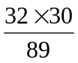 = 10.78) | 10  (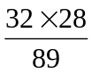= 10.06) | 15  (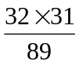=11.14) | 32
Catholic | 9  (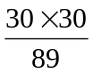=10.11) | 10  (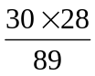=9.44) | 11  (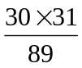=10.45) | 30
Jews | 14  (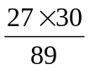=9.10) | 8  (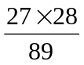=8.49) | 5  (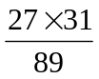=9.40) | 27
Total | 30 | 28 | 31 | 89

- Degrees of freedom, df = (3-1)(3-1) = 4
- χ² = 7.576
Cramer’s v = = 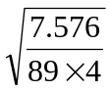 = 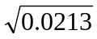 = 0.145
=> The effect size is small

- Critical χ²_{critical} = 9.49 at p = 0.05 for df = 4
- The test is not significant.
- Adjusted residuals not applicable.
- Conclusion:
A randomly selected 89 subjects were to test whether child rearing styles are same among the three religions, Protestants, Catholics, and Jews. Observed and expected frequencies are shown in the above contingency table. Using SPSS for Windows a chi-square test of independence was executed and found a non-significant result [χ² (4, N=89) = 7.576, p = 0.108]. Cramer’s v was calculated as 0.145 that indicated a small effect size. That failed to reject the null hypothesis that there is no relationship between child rearing styles are same among the three religions, Protestants, Catholics, and Jews. Thus, it was concluded that the study result produced no evidence that there is a relationship between child rearing styles and religious preference. In other words, the study result indicated that child rearing styles are independent of the religious preference.

